Autonomous Route and Mapping 2D - 3D Lidar Scanning

Design Document

Calin Doran

2019

Table of Contents

[Introduction 2](#_Toc48045000)

[Technologies 3](#_Toc48045001)

[C++ 3](#_Toc48045002)

[RPLiDAR SDK 3](#_Toc48045003)

[Visual Studio 2019 3](#_Toc48045004)

[Doxygen 3](#_Toc48045005)

[Additional Packages 4](#_Toc48045006)

[Python 3.7 4](#_Toc48045007)

[SQL 4](#_Toc48045008)

[Visual Studio Code 4](#_Toc48045009)

[GUI Prototypes 5](#_Toc48045010)

[Main GUI 5](#_Toc48045011)

[Warning and Directional UI 6](#_Toc48045012)

[Mapping GUI 7](#_Toc48045013)

Introduction

This document contains an overview of the technologies used to produce the A.R.M Lidar System, including the relevant UML diagrams, class diagrams and sequence diagrams. The document will also cover the proposed database schema, with some proposed prototype GUI screens.

Technologies

C++

C++ is a cross-platformed language that can be used to create sophisticated high-performance applications. The language gives programmers a high level of control over system resources and memory.

* This will be the main languge of the system and will be developing most if not all of the functionality of the system with this language.

RPLiDAR SDK

This is the library used for the LiDAR scanner, it allows for multiple commands and access to the LiDAR and its capabilities.

* The SDK of the hardware used, RPLiDAR, is an integral part of this project as it allows for the development the system with the hardware.

Visual Studio 2019

Visual Studio is used to develop apps for Android, iOS, Windows, web, and cloud. It allows you to debug and diagnose with ease, test code, and release stable versions.

* Our IDE, this allows us modern functionality and security while developing our system while allowing full compatability with new and older systems.

Doxygen

Doxygen is a documentation generator, a tool for writing software reference documentation. Doxygen can cross-reference documentation and code so that the reader of a document can easily refer to the actual code.

* Our documentation generator for the full project report.

# Additional Packages

The packages outlined below will be used later in the project depending on the time and resources allowed, and what additainal functonality could be added to the system.

Python 3.7

Python is a high-level, general-purpose language that places an emphasis on code readability. It is capable of supporting multiple programming paradigms such as object-oriented, imperative, procedural etc.

SQL

SQL commands allow you to create a host of components such as tables, schemas, stored procedures, indexes, domains, character sets, or even new databases.

Visual Studio Code

When using multiple languages like Python and C++, it can be a great editor tool, it provides the ability to debug and use version control through a multitude of extensions and addons.

GUI Prototypes

## Main GUI

The GUI of the application would be very simple, it needs to be as fast as possable for the user as it gives the field of view of the LiDAR in 3D, from the 2D data captured from the LiDAR scanner. However, because this view is represented in 3D this will alow the user a better understanding of what the data is and how it looks to the LiDAR itself, this also lends itself into the option of mounting the LiDAR to the top of a mobile unit.

Mounting the LiDAR on a mobile unit like an RC car would alow the user the ability to see from the point of view and give commands to the RC car in real time, or have a set of instructions for the mobile unit itself.

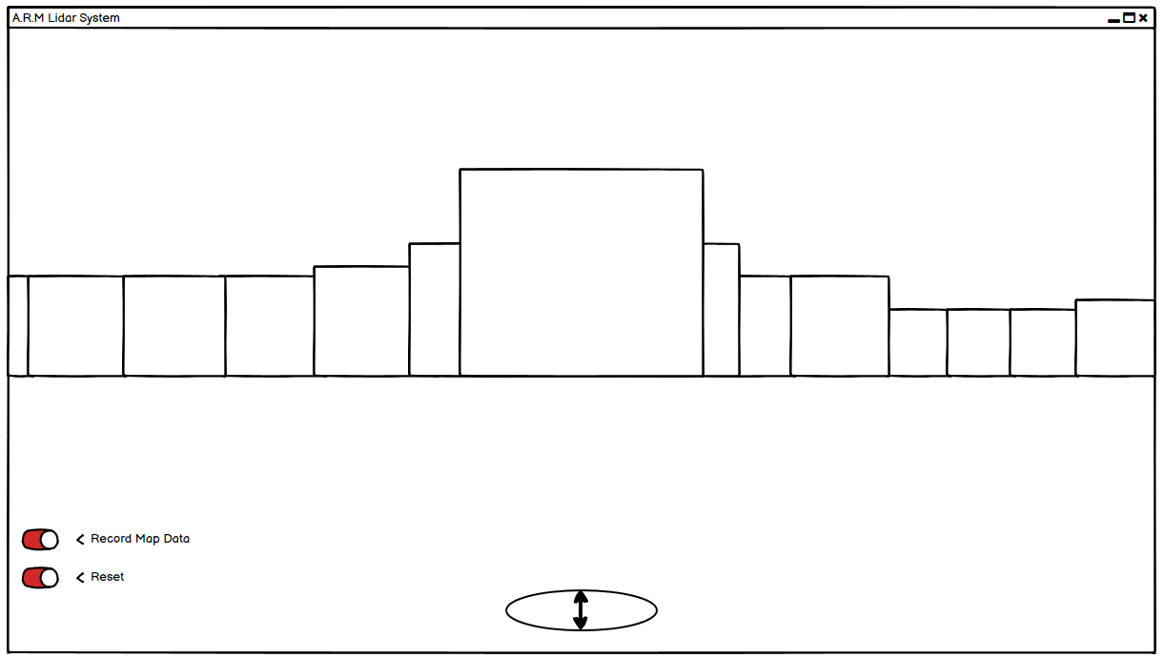

## Warning and Directional UI

Whitin this GUI there could be warnings to show the user that they are getting to close to an object or to stop and move left or right if possible. This is in part is the autonomas aspect of the application.

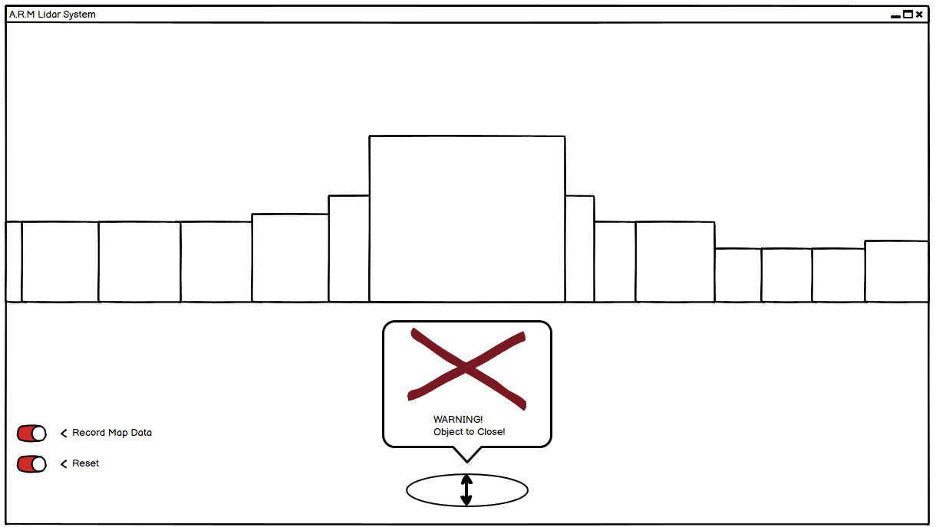

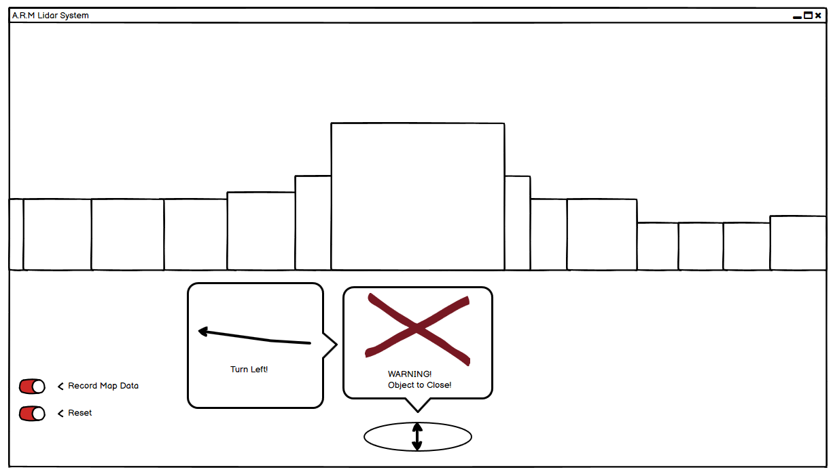

## Mapping GUI

The mapping GUI could be an on screen display that allows the user to capture the data that the LiDAR is showing in its view. This could alow us to generate a map based on what has been seen within the LiDAR’s field of view.

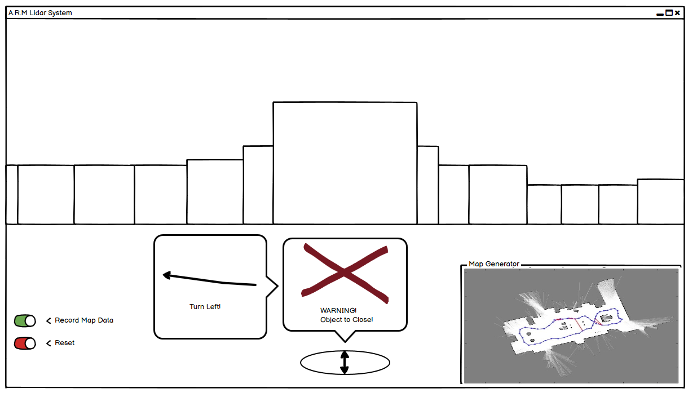

Machine generated alternative text:
 
 
 
 
 
 
Work submitted for assessment which does not include this 
declaration will not be assessed. 
 
 
DECLARATION 
 
*I declare that all material in this submission e.g. thesis/essay/project/assignment is 
entirely my/our own work except where duly acknowledged. 
 
*I have cited the sources of all quotations, paraphrases, summaries of information, 
tables, diagrams or other material; including software and other electronic media in 
which intellectual property rights may reside.  
 
*I have provided a complete bibliography of all works and sources used in the 
preparation of this submission. 
 
*I understand that failure to comply with the Institute’s regulations governing 
plagiarism constitutes a serious offence.    
 
   
 
Student Name: (Printed) ____________________________________________ 
 
Student Number(s):  ____________________________________________ 
 
Signature(s):   ____________________________________________
   
 
Date:    ____________________________________________ 
 
 
 
 
------------------------------------------------------------------------------------------------------- 
Please note: 
a)
 
* Individual declaration is required by each student for joint projects. 
b)
 
Where projects are submitted electronically, students are required to type their name 
under signature. 
c)
 
The Institute regulations on plagarism are set out in Section 10 of Examination and 
Assessment Regulations published each year in the Student Handbook.
 
INSTITUTE
 
of
TECHNOLOGY
CARLOW


29-11-2019

Calin Doran

C00220175

Calin Doran